"WELCOME TO MY SITE!"

My Contacts:

**Email: vijaydidmca@gmail.com**

contact: 8966970139,8770195486 (india)

address: Vijay Shankar Tiwari,

Behind Reliance petrol pump, katangha coloby, Panagar, Jabalput, MP, India.

------------------------------------------------------------------------------------------------

This site contains some precious subjects and ideas for you,either you can get them in pages or go for blogs. These subjects and ideas contains:

1. Predict any natural disasters like earthquake, tsunami, volcano etc.

12. Theorem: That by using s/w we can not increase processor speed in fully optimized system.

14. How to predict SHARE MARKET, business ups and downs.

And various other useful facts............

vijaydidmca@gmail.com

If anybody has any doubt or sees any impractical behaviour in any of my blogs, or getting any difficulty in implementing them, then he may contact me, so i will give you help at my best.

I would like to say, that if any one takes interest in any of my blogs then i will be with him, until unless he reaches to the final destination, i.e. my idea will be implemented to him with his own satisfaction.

You will find my blogs implementing immediately in front of your eyes, if you read them with "why not?" attitude instead of "why?" attitude.

There is one another reason that i ask for deserving fees, "if you have a genuine diamond of 100 $ then you can sell it in market in 200 $ but you can never sell it in 10 $, why?, simply, because the customer will have doubt that this diamond is so cheap that it is either duplicate or stolen".

Again; if anyone gets success in implementing any of my ideas, then congrates!, further if he accepts that my ideas anyhow helped him and i deserve some fee for that, then he may contact me at:

vijaydidmca@gmail.com

Mobile: 8966970139,8770195486 (India).

resident:

Behind reliance petrol pump,

Kantngha colony, Panagar, Jabalpur, MP (India).

**How to predict earthquake**

|  |  |
| --- | --- |
| Posted by [Vijay Shankar Tiwari](http://vstiwari.webs.com/apps/profile/44586293/) on 01 May, 2018 |  |

Hello to all visitors,

I have invented and proposed the usefulness of the random graphics.

that we can use it in many aspects (e.g. to predict natural disasters, like earthquakes, volcanoes and even in predicting business ups and downs).

here i am again using logic to find out when earthquake will hit to a particular region or country again.

Stay for a moment! Must take care, i am not talking that "I will predict when earthquake will strike to a particular region by using random logic".

i am very sure the seriousness of the subject i am talking about and i make you ensure that we will predict earthquake not by using random behavior of the graph but we will sort out "every" cause or reason that is responsible for the earthquake and this prediction will be depend upon every (i am saying "every") reason of the earthquake, whether it is discovered by the current science or not.

As much i know, the most responsible reason for earthquake is:

"When two plates deep under the surface of earth, slips over each other than the energy that stores between them releases itself in the terms of vibration in the earth surface, and that’s called earthquake" and many other factors as well.

So here we will find out when the next earthquake will strike to a particular country.

i will not specify country names, because in that case it might be a critical issue, so i will mention countries only by c1,c2,c3....and so on.

Before go to that very important issue we must understand what is the random logic or random graph or they are really useful or not.

Or how much reliable they are?

So what is the random logic?

"Random logic is the logic that does not follow any logic".

Random graph do not create any patterns why? I am going to describe after some while.

Now i will add some more firm facts to keep my side more strong.

Now what is the random logic or random graph?

1. Random logic is the logic that does not follow any logic.

2. Random graphs do not create any pattern.

Now how can we say that? i will prove that here, so that no doubt or confusion will be remain in any mind.

Just see what the logic is.

For examples:

a. y = x power 2;

Now how will be the graph?

**Please refer diagram a.**

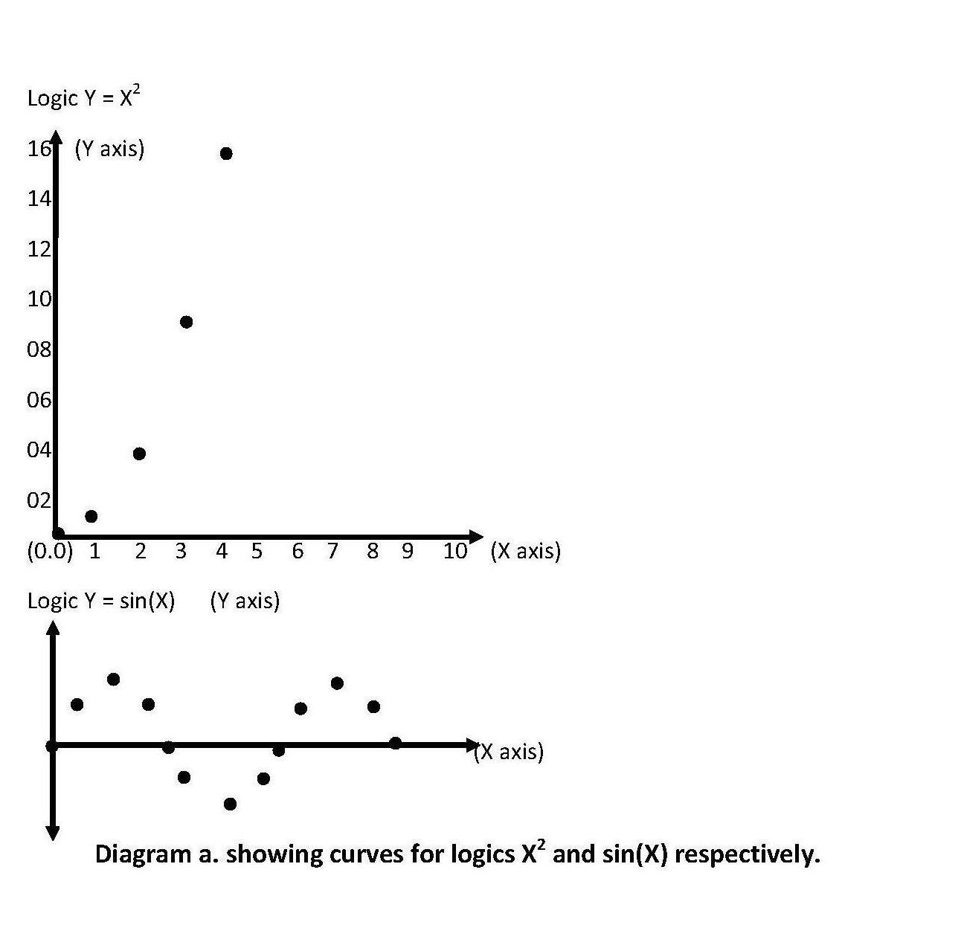

In above graph logic "x power 2" says that the graph will follow a particular pattern always. "As you can see a parabolic curve." in the above first graph.

Or for example:

b. y = sin(x);

**Please refer diagram a.**

in above graph logic "sin(x)" says that the graph will follow a particular pattern always. " as you can see a curve wave" in the second graph.

So it is the fact that whenever there will be a logic then there will appear a pattern according to that logic.

So every logic has its own pattern.

But Random logic does not have any logic so its proof that they will never follow any particular pattern "in any condition".

So now it has been proven, that random logic does not follow any pattern "in any condition".

Notice, that i am telling "in any condition" (please keep that remember, because this term will be used later in very useful situation).

By telling "in any condition", i want to say that whatever practical you can try or whatever experiment you can do, try (for example putting same random graphs one after another vertically or horizontally, but you never find that this combination of random graph will follow any patterns) or any other experiment that you can do try it.

But must take care some may say that i did an experiment and my random graph is now following patterns, for example:

Suppose one random graph is as given in **diagram b.:**

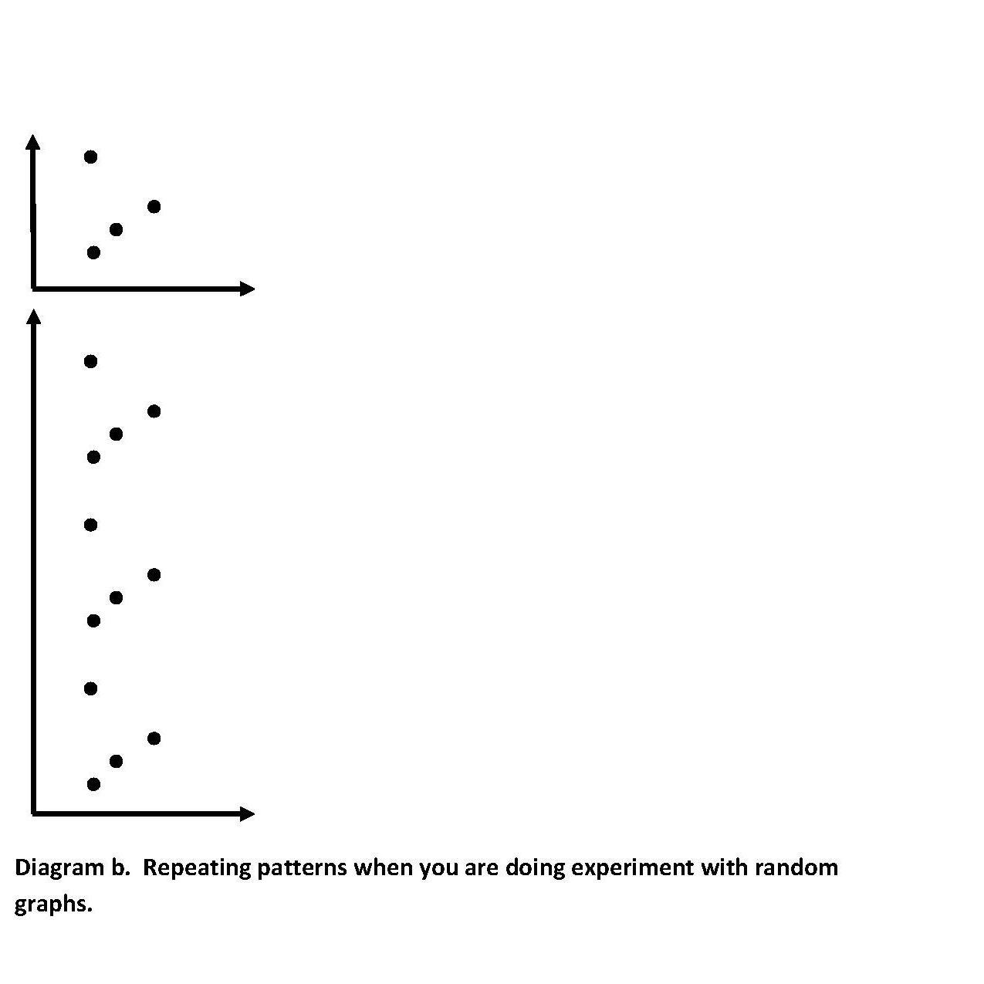

Now anybody may concatenate this graph vertically a few times and saying look these patterns:

i agree! that this is a pattern and now it follows the logic (that after every 5 steps every dot will be repeated vertically i.e. 5y)

but i am not talking about these repeated patterns rather i am talking about patterns other than "this only repeated pattern” that can be generated using logical graphs". for example there are lots of patterns like straight line, triangle, square, circle, parabolic curves, sin wave, tangent wave, e power x, log 2 (x), log 10 (x), etc. Can you generate anyone of these patterns, by doing any experiment in random graphs? No, never. So i am talking about these patterns (i.e. other than that only repeated pattern which is generated by only logical pattern).

so it has proved also, that whatever experiment we can do, do. But we can never generate a particular pattern using **random graphs**.

Must take care that in above graph the "y" is repeating itself just after every 5th time (i.e. 5y), so how can you know that y is repeating itself because of concatenation of graphs one above another or if really there is a chance or any logic that after every 5th time the earthquake will again strike in reality.

So how can you differentiate between them? The answer is very simple go to the history search whether this logic indicates for earthquakes or not.

if yes then keep it with you or otherwise ignore it.

Stay! Here one may ask why you are taking so much care in this article, it is because in this article we are searching for a way to save thousands or lakhs of lives.

Now the basic question arises, is it valid to take help of random graphs, when the issue is so critical, Now i am answering in fact bitter truth is that it is the "one and only" way to predict these natural disasters.

But how can i say that?

"i am not saying that rather i am going to prove that".

Look what is the random logic?

Earlier i have said that random logic is the logic that does not follow any logic.

Is it true? No, never. In fact "random logic is the logic that human mind couldn't understand".

"Because nothing is logic less in this universe and beyond the limits of this universe".

So what is happening today. Today scientists are making graphs and trying to understand when the next earthquake will strike again. but what they are getting; as soon as they make any graph; they find no logic in it and say that it is a random graph so we cannot do anything in that case. but it is not a random graph, there must be some logic but we couldn't understand that.

But how can we say that?

Let's see.

Suppose one logic says that after every 5 years the pressure builds between plates and it causes the plates to slip over each other and in this way the earthquake will strike.

and other reason says that even if the pressure is enough but the surface structure of the earth of that particular region is strong enough (just like in case of granite rocks) that it can tolerate that pressure.

Now the scientists know only one reason (the first one, suppose).

And now they make a graph according to that and find that the next earthquake must strike just after 5 years; they start making a graph but find that after 5 years there is no earthquake, and they start talking that it follows random graphs, and in that case they cannot do anything.

But is it random? No, we said that random because we couldn't find 100 % reasons; because that graph is made up of two logics first one is

"When the pressure will build?" and the second one is "how strong the surface structure is?”

So why we are not able to predict earthquake? The answer is, because we do not know the 100 % reasons of earthquake striking.

So if we find 100 % reasons; then we can predict the earthquakes? The answer is self-explanatory.

Now stay again!...

What we have proved?

1) First, random graphs do not make any patterns in any condition or under any experiment.

2) Nothing is random in this universe and beyond its limits.

For example string 2,8,26,62,122.......will be random for some people who couldn't understand that.

and it will be logical for people who got success in understanding that it follows the logic "x power 3 - x + 2".

That’s why all scientists have their own, individual and personal level in understanding things. And one scientist’s level will of course differ from other's one.

3) Until unless we know 100 % reasons of causing earthquakes these graphs will be random for us. So it is the "one and only" way to predict earthquakes. What is am describing ahead.

Now as i have said earlier i have proved that using random graphs is the "one and only" way to predicting earthquakes or any natural disasters like tsunami, volcano, twisters etc.).

Because in simple words, "until unless you do not know 100 % reasons, go for random graphs".

Now keep some things in mind that my prediction will not depend upon random logic, rather it will find 100 % reasons of causing earthquakes then we will predict when an earthquake will strike to a particular region.

And if the reasons are 100 % then you can understand how much will be the probability of striking earthquake to a particular region.

The answer is probability "1". (I.e. 100 % surety).

Now the topic has become very interesting, let's find how much i get success in following my words (i.e. 100 % surety).

Now start:

Make a random graph (calling "random graph", because we don't know logic behind it)

Please refer **diagram c.**

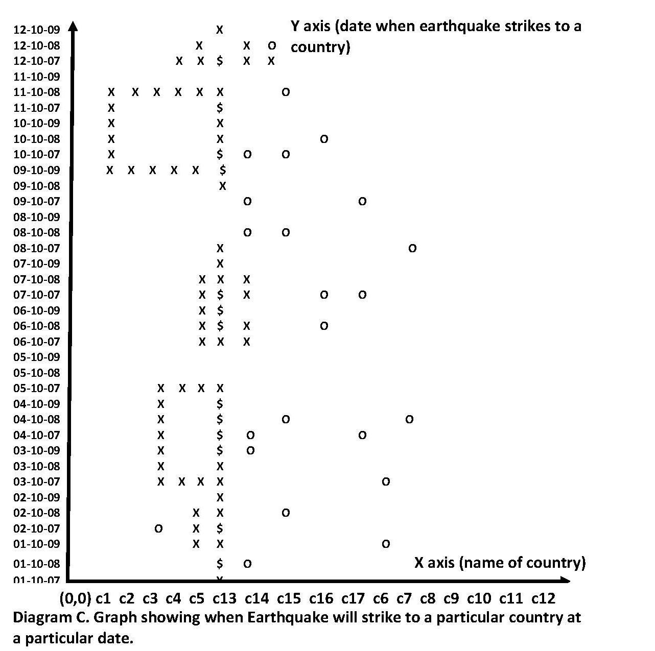

Now in our graph that i built, keep an eye on dates in what manner they are arranged, here we are doing an experiment with random graph by putting dates in that manner (other than natural manner, because natural manner says that dates should be in ascending order), and becasue we are doing experiment with the random graph so there may produce one logic according to that experiment (so search the history whether earthquakes are occuring in that logic or not, if yes than consider that logic also (so that 100 % surety) or otherwise ignore that (so that 100 % surety).

keep an eye again on the countries they are not arranged in alphanumerical order (but here we have used some other logic for example countries c13,c14,c15,c16 and c17 are the most **sensitive** countries for earthquake so we grouped them together just between the graphs this would help us for analyzing these countries because we are going to analyze them in terms of patterns. so in our graph countries are divided in three groups

1) Countries c13, c14, c15, c16, c17 - most sensitive for earthquakes.

2) countries c1,c2,c3,c4,c5,c8,c9,c10,c11 - most safe countries( either there earthquake never occurred or in the opinion of scientists these countries are most safe

countries).

3) c6, c7,c12 - not sure (50 - 50 possibilities).

Now before go ahead please refer my blog 100% hit ratio in RAM paging. Given next

 --------------------------------------------------------------------------------------------------------------

**♦ How can you get 100 % hit ratio using random graph?**

**Explanation:** So the conclusion is that every algorithm is made up in following manner:

        logic L1 + logic L2 + logic L3 +.......logic Ln + random Logic = 100 % hit.

if we compare this theorem with LRU then we find:

       LRU logic (i.e. Most heavily used pages) + random logic = 100 % hit.

if we compare this with FIFO then we will find.

     FIFO logic + random logic = 100 % hit.

and same for all others algorithms.

        so the story says if in any way we become able to get that random logic then every time we will find 100 % hit ratio.

So how will we get that random logic?

answer is very simple; by using the only behavior of the random logic; that it does not makes any particular pattern.

so make a graph using page no. in one axis(X axis) and no. of times they have been used in other axis(Y axis). and fill the data and take care the occurrences of data must not make any particular pattern, if any page makes forces making of a particular pattern then  immediately remove that page from cache memory and fetch other useful one.

-------------------------------------------------------------------------------------------------------------

Here we have to prove "opposite", that any event (in this case "earthquake") "must occur" with 100 % (practically 80 %) probability in any particular condition (in this case date).

Because proving that earthquake must not occur in any particular date to any particular country, makes no sense and actually it is a foolish thing to do.

So here we have to prove when an earthquake will strike to a particular country with 100 % probability (theoretically), practically is should be between 80 to 85 %).but this high percent will depend upon some factors, and these **factors** are total in control of us, so how much intelligence and with hard work we will provide to these factors the better probability we will get.

The main formula that we will follow is:

Summary: Most safe conditions - Most sensitive conditions + random logic = 100 % reasons.

In my included software we will follow the same concept.

In X axis we will take **date** in Y axis we will take **location**, and then we will take any particular pattern in textboxes (Run my software and see). By clicking **LOAD** button.

Then click on **Earthquake** button (Or share market or tsunami or volcano, In other words any event that’s occurrences depends upon random logic (say). Then you will see patterns with which we can conclude the occurrences of these events.

i will indicate these factors when they will occur in understanding and implementing the whole process, specially.

look random graphs never make any patterns so when in the graph it "seems" (factor1, after how many dots you take decision that now it is going to create a pattern) that there is occurring any pattern (factor2,how intelligently you select the pattern) in the graph then make sure (90 %) that, that dot will never occur in the graph, but that dot, means that at that dot earthquake will never occur to the crossing point ( i.e. at that date x to that particular country). but "this information" makes no sense because you have to discover when the earthquake will occur at any crossing point.

Now here you are 100 % wrong! "This information" is very useful for us(i.e. when earthquake will not strike to a particular date to a particular country)

But how?

Suppose there are 1000 people in your country, 200 of them are suffering from "flu" you make an announcement that all people who have "flu" come to the health dept. register their names and be admit in the hospital. But they will never come to you, and this happens in every case, so what is the solution. the solution is make an announcement that people who are not suffering from "flu" come to the health dept and register their names. They will immediately come. Now you have got 800 people who do not have "flu". Subtract them from 1000, it means all other people whose name are not register in the health dept. are suffered from "flu". Now you have got them, now do proper action.

Same is with "earthquakes"! Do you know which countries are ill (sensitive for earthquake or to you know 100 % reason of causing earthquakes).

The answer is no. so make a list of those countries which are totally safe from earthquake (factor3! how efficiently you sort out these countries).

Look! If there are 500 countries in this world and you get list of 400 countries that are 100 % safe from earthquakes, so ultimately you got a list of 500 - 400 = 100 names of those countries which are 100 % sensitive or suffered from earthquakes. In that case every cause (100 % reasons) will come under the consideration.

Take care! Can you find 100 % reason of occurring earthquakes, no, so find 100 % reasons of not accruing earthquakes?

Because if z = x + y;

You know z = 500 if you discovered any one of x and y then ultimately you will find another one.

So in my graph we can find with 100 % guarantee that earthquake will not occur to any particular country to any particular date. So keep searching that continue at last what you will find?

Answer is simple x = z - y, which is at last those countries, will remain where earthquake will strike at a particular date with 100 % guarantee.

To any particular country with 100 % guarantee. Look in our example we have include countries with 50-50 possibilities (factor4! the less the numbers of these countries the more the probability that we will find the earthquake striking accurately).(that is try your best to put these countries either in the most safe or in the most sensitive countries).

Now start building the graph:

In this graph we marked the sign "x" where we will discuss and other signs are marked by "o".

Now be most careful here! Now i am going to tell the method how to make these graphs predictable with near about 95 % guarantee.

Let’s see:

We can make any pattern for those countries freely which are most safe countries. Because pattern says that these countries will be most safe and because these countries are most safe so that we can make any pattern for them in the random graph.

we are sure that countries c1,c2,c3,c4 and c5 are under the most safe countries so we can mark anywhere in the graph for these countries or we can make any pattern freely for these countries because we are sure that earthquake never strikes to these countries and creating patterns in the random graphs for these countries will mean the same(because any pattern says that earthquake will never strike to those countries and because earthquake never strikes to those countries so that we can make any patterns for those countries as our wish), this mark or these patterns will say that there will never occur an earthquake in this country, now make marks or patterns for these (most safe) countries and try to include most sensitive countries into these patterns. so when a most sensitive country will be included in a pattern then be 98 % sure that there will never occur an earthquake in that most sensitive country for that particular date (even if it is most sensitive for earthquakes), now make as many patterns in the same manner and try to include most sensitive countries in those patterns. So wherever a most sensitive country will be included in to pattern, immediately conclude that the earthquake will never strike to that particular country at that particular date with 90 % guarantee (Because keep in mind that occurring earthquake is a random logic (say), and so there occurrence will not make any patterns, because random graph does not make any pattern). Keep this process continue. and when you find that creating more patterns in this manner is not possible now, then the remaining dates that are not included in any pattern will be the most sensitive or most dangerous dates for that country, so that, that country needs to take must care at those dates.

For example in the graph countries c3, c4 and c5 are the most safe countries so we created a pattern (look at dates from 03-10-07 to 05-10-07 carefully! must see!)

That is a square; and in the process of creating this pattern we included the most sensitive country c13 in it (look at dates from 03-10-09 to 04-10-09 carefully! must see!). you can look "$" (must see in the graph!) signs in the graph, these signs are the places where we have included most sensitive countries into the patterns (those patterns which are created by using most safe countries and marks that are already in the graph because of occurrences of earthquakes at that particular point).

In this graph concentrate on country c13 (it is under the most sensitive country).there seems that if some patterns are occurring. For example if earthquake comes at where there is $ sign in the graph, then there will create some patterns but random graphs never create (with 98 % probability) patterns. so the earthquake will never strike at that particular sign "$".

so if we subtract that sign with the total (just like z = x + y. so x = z - y). then we will find that the most sensitive dates for striking earthquakes at country "c13" are "05-10-09", "08-10-09" and "11-10-09".(suppose current date is "30-09-09").

In other words people "$" have registered their name that they do not have "flu" now you can easily find who are suffered from "flu".

**Now read the following sentence with very carefully** and with must take care:

"Now country c13 has said that at date "$" there are 100 % reasons (whether scientists could understand them or not) that earthquake will never occur or in other words country c13 is saying that at dates "05-10-09", "08-10-09" and "11-10-09" there are 100 % reasons (whether scientists could understand them or not) that there will be striking of earthquakes".

Now must take care, did you notice one thing that "are we calculating the things with random logic when there is matter of thousands of, lakhs of lives?"

No never! Instead we are calculating them with 100 % reasons or causes that are responsible for producing earthquakes.

That’s why! I say that this method is the "one and only" method for predicting natural disasters with near about 95 % surety.

Take care; this percentage depends upon factors that i have noticed while reading this article.

**Here, one point that you must notice that we are subtracting most sensitive countries from most safe countries. Did you notice? In this way, ultimately we have reached all; I said all reasons which are responsible for producing earthquakes. Because in this way we are subtracting all reasons from no reason (i.e. most safe) this is not a normal subtraction, rather we are subtracting most safe conditions or situations or reasons with most sensitive reasons. In this manner we are (or our software program) taking into consideration earthquake conditions or situations or reasons ultimately.**

Stops writing!

My suggestion is go for this method if you want to predict any natural disasters. Because this is the "**one and only"**method if you don't know 100 % reason.

Summary: Most safe conditions - Most sensitive conditions + random logic = 100 % reasons.

Precautions:

1. Your software performance depends upon how intelligently you choose data in X and Y axis.
2. In textboxes you must fill values according to any particular pattern.
3. Then in coding (e.g. button_click) you must take a random function. The random function generated by system or s/w.
4. Include at least one random function in multiplication or division with values stored in textboxes.
5. All pattern values (i.e. all textboxes values) must participate in multiplication or division with values generated by random function.

If any queries, then freely contact me at:

8770195486 (India),

8966970139 (india),

[vijaydidmca@gmail.com](mailto:vijaydidmca@gmail.com)

[vijaydidmca@yahoo.com](mailto:vijaydidmca@yahoo.com)